Instructional Plan: Data Cleaning

Steps of the Data Cleaning Process
Real-world data is messy. Sometimes the naming gets messed up, sometimes the data is corrupted, and sometimes the included data may hurt the model rather than help it. Data needs to be cleaned before fitting into a model, not as an afterthought, but as a primary consideration in running the model.
The CIFAR-10 dataset we are using is a benchmarking dataset, and the checks for these things will likely pass. Yet it is important to verify this.

Handling Noise in Images
There are random variations in pixel values that have nothing to do with the actual visual information. Sometimes it is due to image compression, sometimes to the camera's sensor limitations, and sometimes to other noise sources.

Figure 1
Noise Comparison
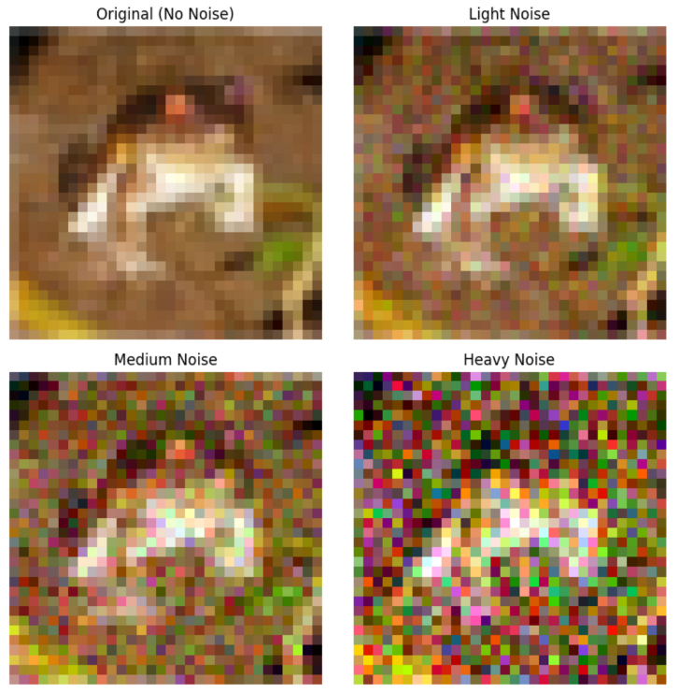
An image of a frog with different levels of synthetic noise added. Created by the author using Python; code refined with assistance from Google Gemini.
Class discussion and collaboration:
-Should we smooth the images to remove noise in the training data?
-If the answer is “no”, ask why, and if the answer is “yes”, ask why. Explain that both can technically be correct. Though noise smoothing via typical methods is not the best bet, there are advanced techniques for removing noise; we will focus on adding noise to the training data through augmentation.

“Data augmentation by noise addition is a strategy that improves the robustness and generalization of CNNs” (Momeny et al., 2021). Also, in work by Sezer and Sezer, a CNN-based noise reduction method was used to reduce noise in an image classification task, and it seemed to improve “the performance of the CNN from 92.29% to 97.70%” (Momeny et al., 2021). So, both strategies can help the model perform better classification. For this project, we will use data augmentation to add noise to the images, allowing the CNN to better understand the images' true features in the presence of noise.

Code – A stack of image augmentations, adding noise is included here
photometric_aug = tf.keras.Sequential([
layers.RandomContrast(0.2),
layers.RandomBrightness(0.2, value_range=(0, 1)),
keras_cv.layers.RandomHue(0.2, value_range=[0, 1]),
layers.RandomRotation(0.1, fill_mode='nearest'),
layers.RandomZoom(0.1, fill_mode='nearest'),
layers.GaussianNoise(stddev=0.05) # This is where we inject noise
], name='PhotometricAugmentation')

Handling Blurriness
Class discussion and collaboration:
-Think of how a CNN works (the layers, and what the model is ‘looking’ for, and think about how blurriness would affect its ability to work properly?
-The convolutional filters are looking for edges and features, and blurriness will make this difficult.
-Please review the following website, which mentions a way to programmatically detect blurry images using the Laplacian score.
-https://pyimagesearch.com/2015/09/07/blur-detection-with-opencv/
Figure 2 - Scoring Blurriness with Laplacian Score
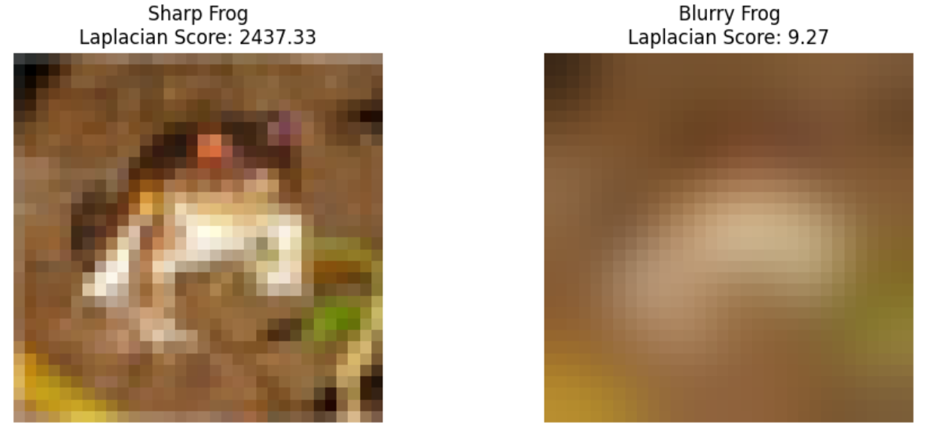
A comparison of Laplacian scores between images of a frog with high blurriness and low blurriness. Created by the author using Python; code refined with assistance from Google Gemini.

We can use this blur-detection pipeline to identify which images are blurry. It is possible that, in a cleaned test dataset, no images will be considered blurry. To find an appropriate blur threshold, one would use trial and error to determine the optimal amount and review sample images to confirm that it is working appropriately. In our situation, we will use a blur threshold of 10.

Code — Blur detection using Laplacian variance
import cv2

BLUR_THRESHOLD = 10.0 # conservative for 32x32 images
blur_flags = []

for img in x_raw: # x_raw: uint8 (N, 32, 32, 3)
grey = cv2.cvtColor(img, cv2.COLOR_RGB2GRAY) # convert to greyscale
variance = cv2.Laplacian(grey, cv2.CV_64F).var() # measure edge sharpness
blur_flags.append(variance < BLUR_THRESHOLD) # True = blurry → remove

blurry_count = int(np.sum(blur_flags))
print(f"Blurry images found: {blurry_count}")

# Remove flagged images
keep_mask = ~np.array(blur_flags)
x_clean = x_raw[keep_mask]
y_clean = y_raw[keep_mask]

The code above determines whether an image is blurry. It does this by applying a 3x3-pixel filter across the image to determine its sharpness. If there are many rapid changes, the image may be considered sharper. If there are fewer rapid changes, the image would be noted as more blurry than sharp. If you imagine the smoothing of pixels in a blurry image, this makes sense.
After the check, if the image is found to be below the blur threshold, it will be removed. This is done for all images.

Class discussion and collaboration:
-The above code runs on all images, then there is a split later into training and test data. Meaning this blurriness check is used on all images. Is this correct, or is this an error?
- Think about this as a quality check, not a data transformation. We want to check the quality of all the images. We will also perform additional data quality checks on both the training and test data.

Handling Occlusions
In images, sometimes something is in front of the subject we are trying to classify. Think of glass blades in front of a frog, or a tree in front of a deer.

Class discussion and collaboration:
-What should we do about images like this? Remove or keep?
-Let the class discuss, the conclusion is that ‘real’ images will have occlusions, so it is important to keep this important feature in the training data.
-It is possible to add occlusions using CutMix augmentation.

Check for Null or Erroneous Images
NaN is poison for a neural network. We need to remove it from the data. NaN means “Not a Number”, and computers use it when an operation doesn’t have a valid answer (like when dividing by zero).

Class discussion and collaboration:
-Let’s have a super easy test
-What is 20/80*2134-312 *12 – NaN
-What is (pi / NaN)*27
-What is 3 – NaN
-Let’s try that with a weighted sum used in the neural network
-output = (0.3 * NaN) + (0.7 * 0.9) + (0.2 * 0.4)
-Let’s try an activation Function
-ReLU(NaN) = max(0, NaN)
-Let’s look at the means squared error
Loss = (NaN – 0.8)²
-Note that they all equal NaN

As mentioned in previous assignments, in a neural network, the input will flow through many operations across all layers. Then there will be a backpropagation step to minimize the loss. NaN values ruin this completely. A single NaN pixel entering the forward pass will make every subsequent calculation undefined. This will continue through backpropagation, affect the activation functions, and ruin the neural network.
For images, we want pixel values between 0 and 255. And for class labels, we want them to range from 0 to 9. Below is a check for NaN values and a ‘sanity check’ to ensure nothing is wrong with the data we are using.

Code — NaN, out-of-range pixel, and label integrity checks
# Cast to float32 first — np.isnan() raises a TypeError on integer arrays
x_float_check = x_raw.astype('float32')
nan_count = int(np.isnan(x_float_check).sum())
print(f"NaN values : {nan_count} {'OK' if nan_count == 0 else 'ACTION REQUIRED'}")

# Out-of-range check — valid uint8 range is [0, 255]
out_of_range = int(np.any((x_raw < 0) | (x_raw > 255)))
print(f"Out-of-range : {out_of_range} {'OK' if out_of_range == 0 else 'ACTION REQUIRED'}")

# Label integrity — CIFAR-10 classes must be in [0, 9]
bad_labels = int(np.any((y_raw < 0) | (y_raw >= NUM_CLASSES)))
print(f"Invalid labels : {bad_labels} {'OK' if bad_labels == 0 else 'ACTION REQUIRED'}")

Checking for unusual Characteristics
We want to make sure all the values are as expected. The CIFAR data set consists of 6000 images of size 32x32 pixels, with pixel values ranging from 0 to 255. We can verify that these are the actual values with the following code. It is also important to check the image class distribution, as different proportions may require a modification of approach.

Code — Shape, dtype, and class distribution verification
print(f"Image shape : {x_raw.shape}") # expected (60000, 32, 32, 3)
print(f"Image dtype : {x_raw.dtype}") # expected uint8
print(f"Pixel range : [{x_raw.min()}, {x_raw.max()}]") # expected [0, 255]

# Class distribution — bar chart in console output
for i, name in enumerate(CLASS_NAMES):
count = int(np.sum(y_clean.flatten() == i))
bar = '█' * (count // 500)
print(f" {i} {name:<12} {count:>6,} {bar}")

Tools and Libraries Used for Data Cleaning
NumPy is used for data-cleaning checks. NumPy’s “astype()” method changes the integer arrays into float arrays, allowing for the NumPy method “isnan()” to check for nulls. This null-checking method examines every pixel value across all images and provides a count of corrupted pixels.
Cv2 is used for the blur detection functionality. It’s “cvtColor()” method allows us to convert the image to grayscale, so that when we run its other method “Laplacian()”, it can determine the variances between pixels, and determine how blurry the image is.
During data cleaning, TensorFlow is used to load the dataset. It is also used to convert integer values to floating-point values (which is useful for the normalization process). Further, after the normalization process, TensorFlow’s “clip_by_value()” is used to ensure that all pixel values are within the appropriate range.

Understanding the image resolution
The provided data description remarks that the images are 32x32 pixels with 3 color channels. We can confirm this with the following code.

Code — Confirming native resolution programmatically
(x_train_raw, y_train_raw), (x_test_raw, y_test_raw) = tf.keras.datasets.cifar10.load_data()

print(f"Image shape : {x_train_raw.shape}") # (50000, 32, 32, 3)
print(f"Dtype : {x_train_raw.dtype}") # uint8
print(f"Pixel range : [{x_train_raw.min()}, {x_train_raw.max()}]") # [0, 255]

The native resolution of 32x32 will work for training the CNN. There is consideration of resizing the images to train with a pre-trained backbone using transfer learning. The requirement to provide a precleaned dataset requires extra consideration. The file size and longer transfer time of images at 224x224 instead of 32x32 were deemed too large an increase. If images are to be upscaled for transfer learning, this will be done in a separate step, or better yet, within the training pipeline.

Goals of pre-processing
We need the neural network to learn efficiently and be stable. To reach these goals, an important step is preprocessing; without it, the loss surface becomes poorly conditioned, and gradient updates become more erratic (Goodfellow et al., 2016).
The image pixels are integers from 0 to 255. Instead of using these large integers, we divide all pixel values by 255.0. This will scale all pixel values to the range 0.0 to 1.0, now as float32s rather than integers. Since the augmentation layers expect a float32 input, we ensure this step is done first.

Code — Normalization
def preprocess(x_uint8, target=TARGET_SIZE):
"""
Converts uint8 [0, 255] images to float32 [0, 1].
Padding occurs BEFORE resizing (Requirement B4).
"""
x = tf.cast(x_uint8, tf.float32) # uint8 → float32
x = tf.pad(x, [[0,0],[2,2],[2,2],[0,0]], # 2px reflective padding
mode='REFLECT')
x = tf.image.resize(x, [target, target]) # resize (no-op at 32→32)
x = x / 255.0 # normalize to [0, 1]
return tf.clip_by_value(x, 0.0, 1.0).numpy()

Packages used to normalize and augment
NumPy is used for integrity checks during normalization, as mentioned earlier in the description of the packages and libraries used in the data cleaning process. The raw pixel arrays are divided by 255.0 to scale all values in the range from 0 to 1. NumPy’s “concatenate()” method is used to merge the original and augmented samples into a single dataset.
TensorFlow’s tf.image module is used for scaling resolution and padding.
Keras_cv.layers is used for more advanced augmentation, like RandomHue, and CutMix (an advanced image augmentation that combines images with the proportion of the images displayed in the data, allowing the model to be more robust).
The “layers” module in the “keras” sub-package of the TensorFlow library will be used for common data augmentations. The different classes in the layers module are used for these augmentations, and they are descriptive. “RandomFlip”, “RandomRotation”, “RandomZoom”, “RandomContrast, etc., all add some variation to the data, with the goal of keeping the model from overfitting, and allowing it to generalize better.

The padding process
We will use reflective padding to ensure. In TensorFlow, the “pad()” method can be used, with the mode set to “REFLECT”. This reflective padding avoids filling the image borders with a constant color and instead mirrors the pixel values at the image border to fill the image. This padding method was chosen because a CNN will be used to try to classify the images. CNNs are great at detecting edges, so the idea of the reflective padding is to limit the introduction of synthetic edges in the image to avoid confusing the model.
The images in the CIFAR-10 are likely 32x32 pixels, as this is a clean benchmarking example. Yet, the padding and resize commands are still in the code, in the correct order, in case the cleaning and resize steps change (e.g., a future attempt to use transfer learning, which would require increasing the image size).
Beyond image resizing, CNNs’ convolutional layers use a specific kernel size to move across an image. The edges will receive fewer passes, and the output channel loses data if no padding is included. By padding the image, the kernel can focus on the entire image rather than the center.
The steps required for padding are to cast to float32 so we can use TensorFlow’s padding operations (which turns the 32x32 images to 36x36 pixel images), then apply the reflective padding, then the resize step (skipped if we will not resize the images), then we normalize the pixel values between 0 and 1.

Figure 3 - Reflective Padding vs Constant Padding
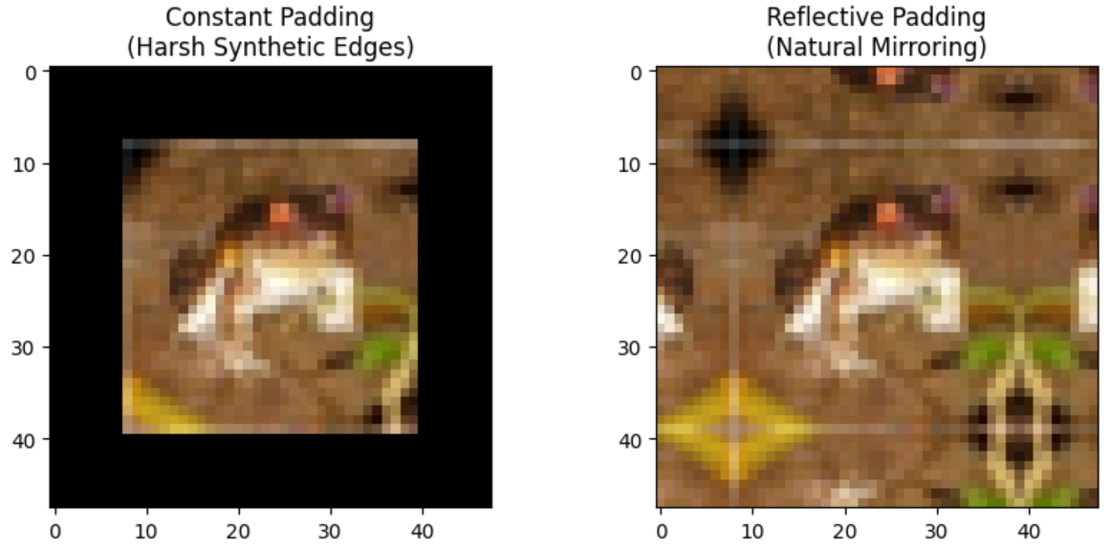
Notice the sharp edges in the constant padding. Reflective padding creates a smoother transition. Created by the author using Python; code refined with assistance from Google Gemini.

Code — Padding before resizing (correct pipeline order)
sample_img = x_clean[0] # uint8 (32, 32, 3)

# Step 1 & 2: Cast to float32, then PAD BEFORE RESIZING
sample_padded = tf.pad(
tf.cast(sample_img, tf.float32),
paddings=[[2,2],[2,2],[0,0]], # 2px each side on H and W; channels unchanged
mode='REFLECT' # mirror pixels — no hard black borders
) # → (36, 36, 3)

# Step 3: Resize AFTER padding
#If not resizing images, use the first line, and comment out the second.
#If resizing comment the first and use the second line
sample_resized = sample_padded
#sample_resized = tf.image.resize(sample_padded, [TARGET_SIZE, TARGET_SIZE])

# Step 4: Normalize
sample_resized = tf.clip_by_value(sample_resized / 255.0, 0.0, 1.0)
# → (36, 36, 3) float32 range [0.0, 1.0]

The number of categories used and the activation function for the final dense layer of the network
Since there are 10 mutually exclusive object classes, the network's final layer will have one neuron per class; for this example, that is a total of 10 neurons. Each of these neurons will compute the logits for each class.
Imagine each neuron as a judge, and they can write their score on a piece of paper and hold it up. The first judge would always judge each picture by how much it looks like an airplane; the second judge does the same, except for birds, and this continues for all classes.
After a few training cycles and backpropagations through the CNN, certain features are starting to help the judges make their determinations. The previous layer in the CNN provides a summary of what the neural network has “seen”. The image of a coasting bird arrives at these final 10 judges. Its outstretched wings, its aerodynamic shape, and its beak make this obviously a bird to you. The judge in front of the airplane neuron is pretty sure this is an airplane by looking at the wings and the sky in the background, so it scores the image at 20. The judge in front of the bird neuron scores the image at 50, as after a few passes through the network, it can clearly distinguish the wings and beak, along with the sky in the background, very clear signs that the image is of a bird. Another judge responsible for finding frogs assigns a score of -30 because none of the features it is looking for are present in the image. The logits can be thought of like these scores.
Taking this further, Softmax will serve as the final judge. It converts the logits to probabilities of certainty. Let’s simplify it by using only the three examples above, where the airplane neuron scored the image at 20, the bird judge scored the image at 50, and the frog judge scored the image at -20. Softmax outputs are .35, .64, and .01. These can be interpreted as meaning that the model is 35% sure the image is an airplane, 64% sure it is a bird, and 1% sure it is a frog. In this example, selecting the item with the largest Softmax value correctly predicted that the image was of a bird.

Figure 4 – Logits and Softmax
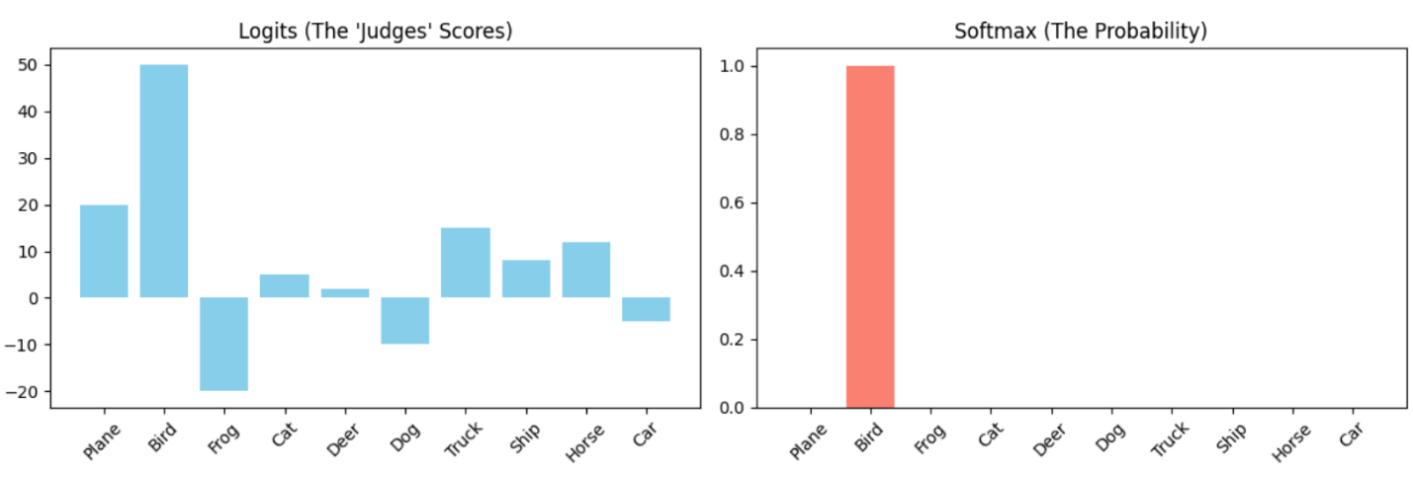
Here, Softmax is so close to 100% for the bird that the probability of everything else is too close to zero to even display. Consider what this would look like if the probability of a plane was 15% higher, and the probability of everything else was 2-5% higher. (Remember, the total should be 100%). Created by the author using Python; code refined with assistance from Google Gemini.

Class discussion and collaboration:
-Notice how the bird is scored at 50, the airplane is scored at 20, and the frog is scored at -20. Why even consider using Softmax if we can just take the max and arrive at the answer?
-Let the students think for a while.
-The item being either “it” or “not it” is a binary choice. The logits and Softmax allow the model to learn more effectively and adjust its weights for improved outcomes. A single prediction could only be wrong or right. But by using Softmax, the model can adjust its weights to arrive at the correct answer. Softmax provides a smooth gradient, allowing the model to know how much to nudge its weights to become more confident.

The steps for preparing data and how it will be divided for training and testing
First, we load the raw data, then merge all the data into a single large pool of 60,000 images. The next step is to run all data quality checks, including checks for NaNs, blurring, and class distribution. We remove all images flagged as invalid, corrupted, or too blurry.
After these data quality checks, we can split the data into training, validation, and test sets before preprocessing. Doing this before preprocessing is meant to protect against data leakage.
For feeding into the neural network, the data is split into a training set, a test set, and a validation set. The training set is where the model looks at the images and labels them with what it thinks the answer is. It adjusts its neurons until it can identify the patterns. This training data is usually a large proportion of the data.
The validation set is used to check progress during training. It tells the model if it understands the features correctly. This is usually a smaller proportion of the data.
The test data is used to provide a final unbiased evaluation of the model's performance. The model has not seen the images in the test data, so there are no hints about what they contain. Further, there is no training on these images, and the model gets only a single chance to determine what the image is. To understand how well the model performs, its performance on the test data is the most important indicator.
Splitting by x and y is simply a matter of the input vs the output. We want to provide the model with X (which would in this case be the images), and to see if it produces the correct Y (the labels in this case).

Code — Splitting the data
from sklearn.model_selection import train_test_split

# Split off 30% for Val/Test combined
x_train, x_temp, y_train, y_temp = train_test_split(x_clean, y_clean, test_size=0.30, random_state=42)

# Split the remaining 30% evenly into Validation and Test
x_val, x_test, y_val, y_test = train_test_split(x_temp, y_temp, test_size=0.50, random_state=42)

Class discussion and collaboration
-How could preprocessing validation and/or test data lead to data leakage?
-Think about an image of a frog in the main dataset before the split. Imagine if we used RandomRotation and RandomHue on the frog image. This would result in multiple copies of the image. The original frog image exists, as does a slightly inverted, slightly different-hued version. During the split, one of these images might end up in the training data, and the other ends up in the test data. Even though the image is different, it still shares many similarities in its basic structure. The model will likely predict this image much more easily, since the “answer” is provided during training.
-Remember, the test data should be “real-world”, untampered images,
That is what the “test” is testing: how well the model can perform on unseen “real” data.
After the split, we will apply normalization and padding consistently across all splits.

Figure 5 – Image Rotations
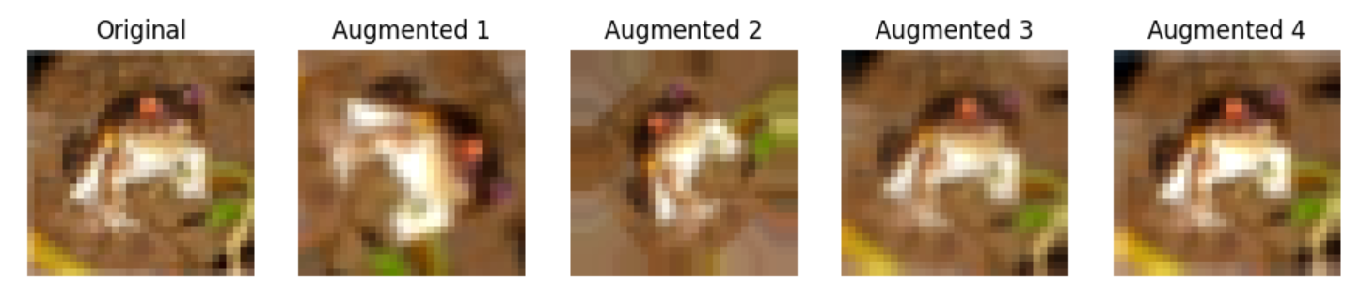
Adding rotations can help the model generalize, as ‘real-world’ images may not be perfectly composed. Created by the author using Python; code refined with assistance from Google Gemini.

Class discussion and collaboration
-Why is it ok to apply normalization and padding to all three splits?
-Normalization and padding do not give further hints about other images in the data set. They do not rely on data from all images (as a global averaging would), and they do not add extra copies that could appear in the training and test data. These are per-image changes, such as dividing all pixel values by 255 and adding a few pixels to the borders of each image, and therefore will not lead to data leakage.

We define the augmentation pipelines to be applied only to the training data. It would be a better practice to do this during training, but for our assignment, we will do it now so we can save the full data set.
The dataset output will be in an “npz” file for use in the training model. This is a compressed file that allows access to the dataset as a single file. Code to audit changes and confirm expected values was added after this file was saved. Further human auditing can be performed if the output is presented in a human-viewable form. Three folders will be output for this task, containing the test, train, and validation images. This output will look like the final images, except that the pixel normalization step would cause the images to be displayed incorrectly. To display the images properly, the code converts the pixel values back to the 0-255 scale. The most important feature to observe is the augmented files; therefore, all the augmented training data was output in a folder “train_augmented”. The “validation_data” and “test_data” folders each contain a 50-image sample from their respective splits.

Code — Saving the final Dataset as an npz file
print("Saving dataset to .npz file...")
np.savez_compressed(
'cifar10_prepared.npz',
x_train=x_train_aug, y_train=y_train,
x_val=x_val_prep, y_val=y_val,
x_test=x_test_prep, y_test=y_test
)
print("Dataset successfully saved to 'cifar10_prepared.npz'!")

Code — Dataset verification
# Load your prepared .npz file
data = np.load('cifar10_prepared.npz')

print("=== FINAL DATASET AUDIT REPORT ===")

# --- SECTION 1: SHAPE & DIMENSION VERIFICATION ---
print(f"{'Split':<12} | {'Count':<8} | {'Shape':<12} | {'Min/Max':<15}")
print("-" * 55)

running_total = 0
for key in ['x_train', 'x_val', 'x_test']:
x = data[key]
running_total += len(x)
print(f"{key:<12} | {len(x):<8} | {str(x.shape[1:]):<12} | {x.min():.1f} to {x.max():.1f}")

print("-" * 55)
print(f"{'TOTAL FINAL':<12} | {running_total:<8} | {'(Matches NPZ)':<12}")
print(f"{'ORIGINAL':<12} | {ORIGINAL_TOTAL_COUNT:<8} | {str(ORIGINAL_IMG_SHAPE):<12}")

# --- SECTION 2: TRANSFORMATION PROOF ---
print("\n=== TRANSFORMATION ANALYSIS ===")

# 1. Padding Check
# Compares final shape (36) to stored original shape (32)
if data['x_train'].shape[1] > ORIGINAL_IMG_SHAPE[0]:
print(f"✔ PADDING CONFIRMED: Dimensions increased from {ORIGINAL_IMG_SHAPE[0]} to {data['x_train'].shape[1]}.")

# 2. Normalization Check
if data['x_train'].max() <= 1.0 and data['x_train'].min() >= 0.0:
print(f"✔ NORMALIZATION CONFIRMED: All pixels are strictly within the [0.0, 1.0] range.")

# 3. Cleaning Check
if running_total < ORIGINAL_TOTAL_COUNT:
print(f"✔ CLEANING CONFIRMED: {ORIGINAL_TOTAL_COUNT - running_total} blurry images were removed.")
else:
print("i NOTE: No images were removed (The dataset was already sharp or threshold was too high).")

# --- SECTION 3: SPLIT PERCENTAGE VERIFICATION ---
print("\n=== SPLIT PERCENTAGES ===")
# Uses the running total of the cleaned data
print(f"Train: { (len(data['x_train'])/running_total)*100:.1f}%")
print(f"Val: { (len(data['x_val'])/running_total)*100:.1f}%")
print(f"Test: { (len(data['x_test'])/running_total)*100:.1f}%")

print("==================================")

output — Dataset verification
Figure 6 – Output from Dataset Audit Report
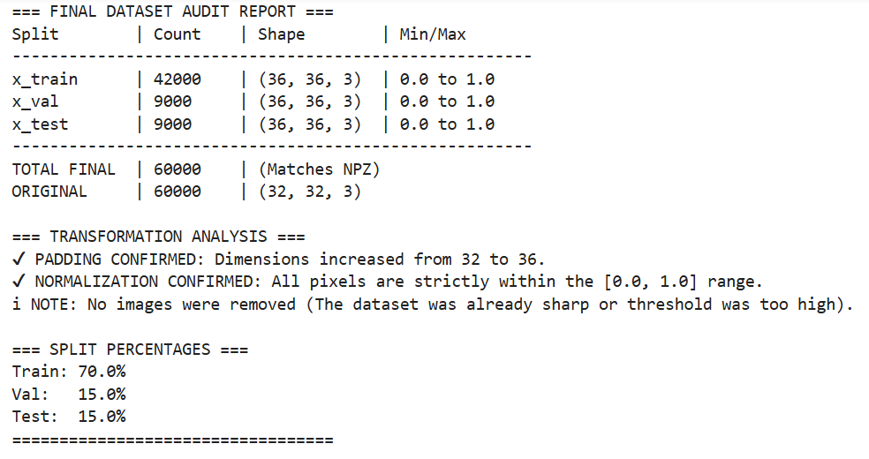
To verify that the transformations were performed appropriately, one should confirm the changes. This will help to determine if there were mathematical or logical errors. These things need to be addressed. Created by the author using Python; code refined with assistance from Google Gemini.

Class discussion and collaboration
-Notice that we started with a total of 60,000 images and ended with a total of 60,000 images. Why not just add the audited images to the original and have a larger training dataset?
-Some benefits of using addition would include allowing the model to have more different views of the same object, and in general, more data can lead to better model performance. If a class is underrepresented, adding some of those underrepresented samples can help to balance the classes.
-Some negatives would include the extra storage and computation needed. Also, there can be an increase in overfitting.
-The decision was made not to add the augmented images as we wanted to promote generalization and keep the overfitting chances low, while not overwhelming the computing resources.
-Further, data augmentation is often done on the fly, meaning that the data can continue to be added to the model with the augmentations. Outputting the data like this (creating a static fixed output) is really done for the sake of the assignment, student review, and understanding.

Code — Export Viewable images
CLASS_NAMES = ['airplane', 'automobile', 'bird', 'cat', 'deer', 'dog', 'frog', 'horse', 'ship', 'truck']

def save_images_to_folder(image_array, label_array, folder_path, max_images=None):
"""
Saves processed images as PNGs. Matches the structure of the .npz file.
"""
os.makedirs(folder_path, exist_ok=True)
limit = min(len(image_array), max_images) if max_images is not None else len(image_array)

for i in range(limit):
# Extract label
label_val = label_array[i]
if isinstance(label_val, (np.ndarray, list)):
label_val = label_val[0]

class_name = CLASS_NAMES[label_val]
file_name = f"{i:04d}_{class_name}.png"
file_path = os.path.join(folder_path, file_name)

# Prevent neon colors with clipping
safe_image = np.clip(image_array[i], 0.0, 1.0)
img_to_save = (safe_image * 255.0).astype(np.uint8)

save_img(file_path, img_to_save)

print(f"Saved {limit} images to '{folder_path}'")

print("Exporting viewable images to match .npz structure...")

# 1. Training (Augmented)
save_images_to_folder(x_train_aug, y_train, "dataset_output/train_augmented", max_images=None)

# 2. Training (Original/Preprocessed only)
save_images_to_folder(x_train_prep, y_train, "dataset_output/train_original", max_images=50)

# 3. Validation Data
save_images_to_folder(x_val_prep, y_val, "dataset_output/validation_data", max_images=50)

# 4. Test Data
save_images_to_folder(x_test_prep, y_test, "dataset_output/test_data", max_images=50)

print("Folder structure now matches .npz keys. Export complete!")

Class discussion and collaboration
-The code was generated with an LLM. What important considerations would you have when creating a prompt?
-The code is provided below. If you have any questions about different functions, feel free to ask questions, or use an LLM to describe how to use.
-Run the code in Google Colab with GPU turned on, or any other online virtual machine to view the output.

Complete Code

#
# ==========================================
# CELL 1: Imports and Environment Setup
# ==========================================
import tensorflow as tf
import numpy as np
import cv2
from sklearn.model_selection import train_test_split
import os
from tensorflow.keras.utils import save_img

print("TensorFlow Version:", tf.__version__)
# ==========================================
# CELL 2: Load and Merge Data
# ==========================================
# Load the raw CIFAR-10 data
(x_train_raw, y_train_raw), (x_test_raw, y_test_raw) = tf.keras.datasets.cifar10.load_data()

# Merge all data into one large pool of 60,000 images
x_raw = np.concatenate((x_train_raw, x_test_raw), axis=0)
y_raw = np.concatenate((y_train_raw, y_test_raw), axis=0)

#Save these for the data audit in cell 9
ORIGINAL_TOTAL_COUNT = x_raw.shape[0]
ORIGINAL_IMG_SHAPE = x_raw.shape[1:] # Stores (32, 32, 3)

print(f"Merged Image shape : {x_raw.shape}")
print(f"Merged Label shape : {y_raw.shape}")

# ==========================================
# CELL 3: Data Quality Checks
# ==========================================
print("Running Data Quality Checks...")

# Check for NaNs
x_float_check = x_raw.astype('float32')
nan_count = int(np.isnan(x_float_check).sum())
print(f"NaN values : {nan_count} {'[OK]' if nan_count == 0 else '[ACTION REQUIRED]'}")

# Check for out-of-range pixel values (must be 0-255)
out_of_range = int(np.any((x_raw < 0) | (x_raw > 255)))
print(f"Out-of-range : {out_of_range} {'[OK]' if out_of_range == 0 else '[ACTION REQUIRED]'}")

# Check for invalid labels (must be 0-9 for CIFAR-10)
NUM_CLASSES = 10
bad_labels = int(np.any((y_raw < 0) | (y_raw >= NUM_CLASSES)))
print(f"Invalid labels : {bad_labels} {'[OK]' if bad_labels == 0 else '[ACTION REQUIRED]'}")

# ==========================================
# CELL 4: Blur Detection and Cleaning
# ==========================================
BLUR_THRESHOLD = 10.0
blur_flags = []

# Calculate the variance of the Laplacian (a measure of edge sharpness/blur)
for img in x_raw:
grey = cv2.cvtColor(img, cv2.COLOR_RGB2GRAY)
variance = cv2.Laplacian(grey, cv2.CV_64F).var()
blur_flags.append(variance < BLUR_THRESHOLD)

blurry_count = int(np.sum(blur_flags))
print(f"Blurry images found: {blurry_count}")

# Filter out the blurry images
keep_mask = ~np.array(blur_flags)
x_clean = x_raw[keep_mask]
y_clean = y_raw[keep_mask]

print(f"Total clean images remaining: {x_clean.shape[0]}")

# ==========================================
# CELL 5: Data Splitting (Preventing Leakage)
# ==========================================
# Split the clean data into Training (70%), Validation (15%), and Test (15%)
# We do this BEFORE preprocessing to ensure the Test/Val sets remain pristine.

# First, split off 30% for Val/Test combined
x_train, x_temp, y_train, y_temp = train_test_split(x_clean, y_clean, test_size=0.30, random_state=42)

# Second, split the remaining 30% evenly into Validation (15%) and Test (15%)
x_val, x_test, y_val, y_test = train_test_split(x_temp, y_temp, test_size=0.50, random_state=42)

print(f"Training set: {x_train.shape[0]} images")
print(f"Validation set: {x_val.shape[0]} images")
print(f"Test set: {x_test.shape[0]} images")

# ==========================================
# CELL 6: Preprocessing (Padding & Normalizing)
# ==========================================
def preprocess_dataset(x_data, target_size=32):
"""
Casts to float32, applies reflective padding, resizes (optional/future-proofing),
and normalizes to [0, 1]. Safe to apply to all splits.
"""
# 1. Cast to float32
x = tf.cast(x_data, tf.float32)

# 2. Reflective Padding (Adding 2px to borders. Batch & Channel dims unchanged)
x = tf.pad(x, paddings=[[0,0], [2,2], [2,2], [0,0]], mode='REFLECT')

# 3. Resize (Currently a no-op if resizing from 36x36 down to 32x32 is intended,
# or kept at 36x36. Adjust target_size if you want to shrink it back down)
x = tf.image.resize(x, [target_size, target_size])

# 4. Normalize to [0, 1] range
x = x / 255.0

return tf.clip_by_value(x, 0.0, 1.0).numpy()

print("Preprocessing splits (this may take a moment)...")
# Apply to all splits evenly
x_train_prep = preprocess_dataset(x_train, target_size=36) # Keeps 1:1 scale with padding
x_val_prep = preprocess_dataset(x_val, target_size=36)
x_test_prep = preprocess_dataset(x_test, target_size=36)
print("Preprocessing complete!")

# ==========================================
# CELL 7: Data Augmentation (TRAINING SET ONLY)
# ==========================================
# We define an augmentation pipeline to introduce variety.
# Applied ONLY to the training set to prevent data leakage.
data_augmentation = tf.keras.Sequential([
tf.keras.layers.RandomRotation(0.1, fill_mode='nearest'),
tf.keras.layers.RandomZoom(0.1, fill_mode='nearest'),
tf.keras.layers.RandomContrast(0.2)
], name='AugmentationPipeline')

print("Augmenting training data...")
# Apply augmentation to training data
x_train_aug = data_augmentation(x_train_prep, training=True).numpy()
x_train_aug = np.clip(x_train_aug, 0.0, 1.0)
print("Augmentation complete!")

# ==========================================
# CELL 8: Save to .npz File
# ==========================================
print("Saving dataset to .npz file...")
np.savez_compressed(
'cifar10_prepared.npz',
x_train=x_train_aug, y_train=y_train,
x_val=x_val_prep, y_val=y_val,
x_test=x_test_prep, y_test=y_test
)
print("Dataset successfully saved to 'cifar10_prepared.npz'!")

# ==========================================
# CELL 9: Final Dataset Verification
# ==========================================

# Load your prepared .npz file
data = np.load('cifar10_prepared.npz')

print("=== FINAL DATASET AUDIT REPORT ===")

# --- SECTION 1: SHAPE & DIMENSION VERIFICATION ---
print(f"{'Split':<12} | {'Count':<8} | {'Shape':<12} | {'Min/Max':<15}")
print("-" * 55)

running_total = 0
for key in ['x_train', 'x_val', 'x_test']:
x = data[key]
running_total += len(x)
print(f"{key:<12} | {len(x):<8} | {str(x.shape[1:]):<12} | {x.min():.1f} to {x.max():.1f}")

print("-" * 55)
print(f"{'TOTAL FINAL':<12} | {running_total:<8} | {'(Matches NPZ)':<12}")
print(f"{'ORIGINAL':<12} | {ORIGINAL_TOTAL_COUNT:<8} | {str(ORIGINAL_IMG_SHAPE):<12}")

# --- SECTION 2: TRANSFORMATION PROOF ---
print("\n=== TRANSFORMATION ANALYSIS ===")

# 1. Padding Check
# Compares final shape (36) to stored original shape (32)
if data['x_train'].shape[1] > ORIGINAL_IMG_SHAPE[0]:
print(f"✔ PADDING CONFIRMED: Dimensions increased from {ORIGINAL_IMG_SHAPE[0]} to {data['x_train'].shape[1]}.")

# 2. Normalization Check
if data['x_train'].max() <= 1.0 and data['x_train'].min() >= 0.0:
print(f"✔ NORMALIZATION CONFIRMED: All pixels are strictly within the [0.0, 1.0] range.")

# 3. Cleaning Check
if running_total < ORIGINAL_TOTAL_COUNT:
print(f"✔ CLEANING CONFIRMED: {ORIGINAL_TOTAL_COUNT - running_total} blurry images were removed.")
else:
print("i NOTE: No images were removed (The dataset was already sharp or threshold was too high).")

# --- SECTION 3: SPLIT PERCENTAGE VERIFICATION ---
print("\n=== SPLIT PERCENTAGES ===")
# Uses the running total of the cleaned data
print(f"Train: { (len(data['x_train'])/running_total)*100:.1f}%")
print(f"Val: { (len(data['x_val'])/running_total)*100:.1f}%")
print(f"Test: { (len(data['x_test'])/running_total)*100:.1f}%")

print("==================================")

# ==========================================
# CELL 10: Export Viewable Images (FINAL VERSION)
# ==========================================

CLASS_NAMES = ['airplane', 'automobile', 'bird', 'cat', 'deer', 'dog', 'frog', 'horse', 'ship', 'truck']

def save_images_to_folder(image_array, label_array, folder_path, max_images=None):
"""
Saves processed images as PNGs. Matches the structure of the .npz file.
"""
os.makedirs(folder_path, exist_ok=True)
limit = min(len(image_array), max_images) if max_images is not None else len(image_array)

for i in range(limit):
# Extract label
label_val = label_array[i]
if isinstance(label_val, (np.ndarray, list)):
label_val = label_val[0]

class_name = CLASS_NAMES[label_val]
file_name = f"{i:04d}_{class_name}.png"
file_path = os.path.join(folder_path, file_name)

# Prevent neon colors with clipping
safe_image = np.clip(image_array[i], 0.0, 1.0)
img_to_save = (safe_image * 255.0).astype(np.uint8)

save_img(file_path, img_to_save)

print(f"Saved {limit} images to '{folder_path}'")

print("Exporting viewable images to match .npz structure...")

# 1. Training (Augmented)
save_images_to_folder(x_train_aug, y_train, "dataset_output/train_augmented", max_images=None)

# 2. Training (Original/Preprocessed only)
save_images_to_folder(x_train_prep, y_train, "dataset_output/train_original", max_images=50)

# 3. Validation Data
save_images_to_folder(x_val_prep, y_val, "dataset_output/validation_data", max_images=50)

# 4. Test Data
save_images_to_folder(x_test_prep, y_test, "dataset_output/test_data", max_images=50)

print("Folder structure now matches .npz keys. Export complete!")

#

Citations

Goodfellow, I., Bengio, Y., & Courville, A. (2016). Deep learning. MIT Press. http://www.deeplearningbook.org
Momeny, M., Neshat, A. A., Hussain, M. A., Kia, S., Marhamati, M., Jahanbakhshi, A., & Hamarneh, G. (2021, September). Learning-to-augment strategy using noisy and denoised data: Improving generalizability of deep CNN for the detection of covid-19 in X-ray images. Computers in biology and medicine. https://pmc.ncbi.nlm.nih.gov/articles/PMC8760424/
OpenAI / Google. (2024). Gemini 3 [Large language model]. https://gemini.google.com

